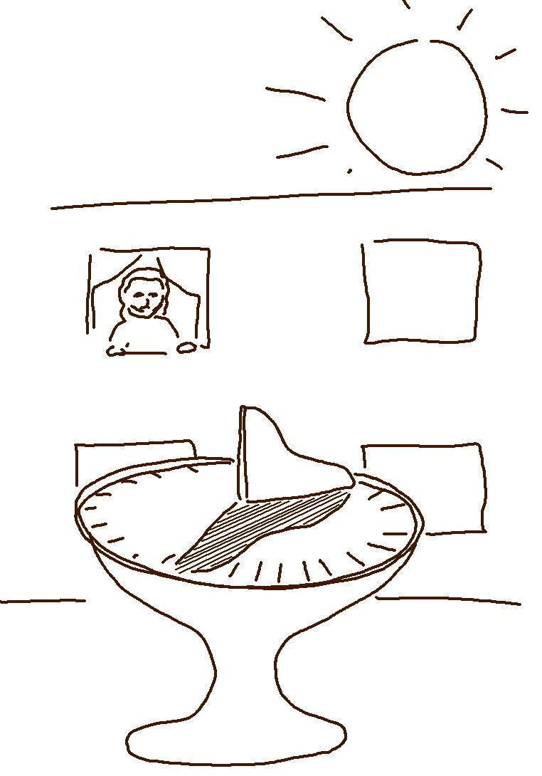
Trust the Lord, and you will be safe.
Proverbs 29:25 _{NLT}

